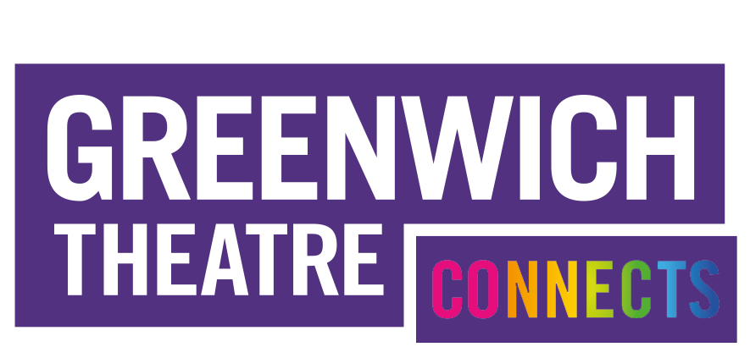

Greenwich Theatre is one of London’s premiere Off-West End theatres, presenting a year-round programme of drama, musical theatre, family shows and pantomime. The theatre is one of the country’s leading supporters of young and emerging theatre practitioners, regularly providing a launch pad for new work which subsequently transfers around the country, into the West End and around the world.
Led by Artistic Director James Haddrell and Executive Director Simon Francis, the theatre is a proud member of SOLT and TMA. The company is a registered charity, supported by grant funding from the Royal Borough of Greenwich. We operate as a small team, with an ethos of forward thinking, proactivity and problem solving.
Our main house features a thrust stage with 400 seat auditoria while our Studio theatre is a flexible 60-seater black box. Across our venues we programme over 400 different productions a year, from very small-scale fringe theatre to mid-scale drama and musicals and the in-house production of one of the UK’s best regarded celebrity-free pantomimes.

As part of the company’s strategy in supporting emerging practitioners we are seeking to recruit our next Resident Technician. This post is designed to give valuable experience and responsibility to someone looking to build a career within technical theatre.

Job Title: Resident Technician
Terms: 12 month FTC
Responsible to: Technical Manager & Production Manager
External Contacts: Visiting Companies, Creatives, Suppliers, Freelancers

Responsibilities
- To be the principle technical contact for all Studio performances and give technical induction to companies on arrival at the Studio.
- To support the safe running of Main Stage get-ins, show running and get-outs of visiting companies and in-house productions including set, electrics and sound.
- To act as duty technician for allocated show calls.
- To support the Technical Manager & Production Manager in coordinating technical resources for all in house productions.
- Together with the Technical Manager, to be responsible for the maintenance of the Theatre’s equipment, either on site maintenance or overseeing regular servicing by contracted professionals.
- Together with the Technical Manager, and the freelance stage management teams, to ensure that all the production areas are kept tidy, safe and fit for purpose.
- To carry out daily and weekly technical checks as required.
- To participate in all training and development initiatives as required
- To attend GT press nights and special events
- To oversee measures to maintain our environment policy (including recycling and monitoring energy use)
- To deputise for the Technical Manager & Production Manager in aspects of their role when they are absent.
- To assist in keeping Greenwich Theatre’s Buildings and Procedures up to date with current Health & Safety regulations and guidelines and sit on the theatre’s in-house Health & Safety committee

Essential
  - A good understanding of setting up sound systems and using Qlab, Yamaha sounds desks
  - A good understanding of carpentry techniques and use of power tools.
  - A good understanding of working with theatre lighting (PAT Testing, basic cable wiring, rigging, DMX and LED wiring, ION Lighting desks)
  - A good understanding of H&S (risk assessments, working at height)
  - Competent with IT (PC and Mac)
  - A team player with the ability to communicate effectively with people at all levels both internally and externally
·
Desirable
- Working at Height Trained (Towers, Tallescope, harness and extendable ladders)
- DBS checked
- First Aid Qualification
- Fire Safety trained

Contract and terms

Title of post: Resident Technician
Salary: £20,000 pa, plus overtime payments
Contract: This is a twelve month fixed term contract
Start Date: July 2022
Probation Period: 3 months
Notice: During probationary period, 2 weeks, thereafter 4 weeks
Holiday entitlement: 25 days plus bank holidays
Hours: This is a full-time position, 40 hours five over six days a Monday-Saturday. Over time payments for Sunday, Bank Holidays, and hours worked over 40 hours per week. Due to the nature of the position, evening and weekend work is a will be required.

For an informal conversation regarding the role please contact Caz Hampton, Technical Manager & Production Manager: c.hampton@greenwichtheatre.org.uk

Closing Date: 10am Monday 27th June

Interview Dates: Friday 1st July

To apply please complete Greenwich Theatre application form and equal opportunities monitoring form, that can be downloaded at www.greenwichtheatre.org.uk/get-involved/vacancies
and send it to:

c.hampton@greenwichtheatre.org.uk
or
Caz Hampton, Technical Manager
Greenwich Theatre
Crooms Hill
SE10 8ES

